__________________________________________________________________

**Central Florida Regional Planning Model**

**Version X.X**

**Model Validation Report**

__________________________________________________________________

**NAME**



**Prepared for the**

**Florida Department of Transportation**

**Updated By**

**Firm**

**Address**

**DATE**

Table of Contents

1. Introduction 5

1. Version Updates 5

2. Data Validation 5

1. Household and Demographic Validation 5

2. Employment Validation 5

3. Network Validation 5

3. Trip Generation 5

1. Trip Purpose Comparison 5

2. Rate Comparisons 6

3. Balance of P’s to A’s 6

4. Trip Distribution 6

5. Mode choice 6

6. Highway Assignment 7

1. Comparison of observed and estimated count volumes 7

2. % Root Mean Square Error 7

3. Visual Validation 7

4. Other Validation 8

List of Tables

Table 1‑1: Version Update History 5

Table 3‑1: Percentage Comparison of Trips by Purpose 5

Table 3‑2: Trip Rate Summaries by Person Trips 6

Table 4‑1: Average Trip Length by Purpose (Observed and Estimated) 6

Table 4‑2: Percent Intrazonal Trips by Purpose (Observed and Estimated) 6

Table 5‑1: Mode Choice Validation Summary (Person Trips) 6

Table 6‑1: Observed vs Estimated Total Volume by Facility Type 7

Table 6‑2: Observed vs Estimated Screenline Total Volume 7

Table 6‑3: Sample % RMSE Report with Acceptable Error Guidelines 7

List of Figures

Figure 6‑1: Scatterplot of Total Model Volume and ADT (Sample) 8

Figure 6‑2: Scatterplot of Total Model Single Unit Truck Volume and Observed SUT Volume 8

Figure 6‑3: Scatterplot of Total Model Multi Unit Truck Volume and Observed MUT Volume 8

Figure 6‑4: Scatterplot of Model Auto Volume and Observed Auto Volume 8

List of Appendices

A. Appendix A: Average Annual Daily Traffic Development (Optional)

List of Acronyms

AADT Average Annual Daily Traffic

BPR Bureau of Public Roads

CFRPM Central Florida Regional Planning Model

DOT Department of Transportation

**FDOT** Florida Department of Transportation

FHWA Federal Highway Administration

FSUTMS Florida Standard Urban Transportation Model Structure

GIS Geographic Information System

HBO Home-Based Other Trips

HBW Home-Based Work Trips

HBS Home-Based Shop Trips

LOS Level of Service

MPO Metropolitan Planning Organization

MUT Multi-Unit Trucks

NCHRP National Cooperative Highway Research Program

NHB Non-Home-Based Trips

NHO Non-Home Other Trips

NHW Non-Home Work Trips

NHTS National Household Travel Survey

PRMSE Percent Root Mean Square Error

RMSE Root Mean Squared Error

SUT Single-Unit Trucks

TAZ Traffic Analysis Zone

TOD Time-of-Day

TRB Transportation Research Board

V/C Volume-to-Capacity Ratio

VHT Vehicle Hours Traveled

VMT Vehicle Miles Traveled

# Introduction

## Version Updates

This section would define what has changed in this version of the model and what has been validated with this edition of the model- outline form.

Table 1‑1: Version Update History

# Data Validation

## Household and Demographic Validation

* Compare to other census/proprietary data
* Plots of district/county comparisons
* Density comparisons
* Persons/HH
* Vehicles/HH
* Workers/HH

## Employment Validation

* Compare to other census/proprietary data
* Plots of district/county comparisons
* Density comparisons
* Persons/HH
* Vehicles/HH
* Validation of Special attractors data

## Network Validation

* Visual inspection of highway links and transit routes
* Speed/# of lanes
* Validation of highway paths-including graphics comparing model to other data like google, etc.

# Trip Generation

## Trip Purpose Comparison

* Percent of Trips In Range to National Numbers/Florida

Table 3‑1: Percentage Comparison of Trips by Purpose

## Rate Comparisons

* Person trips per household and by purpose/market
* Work Trips Per Employee
* Attractions Per Employee

Table 3‑2: Trip Rate Summaries by Person Trips

## Balance of P’s to A’s

* Ratio of P/A
* Plot of P’s and A’s estimated vs observed

# Trip Distribution

* Validation comparison of function parameters
* District to District Summaries
* CTPP comparison for work trips
* TLFD plots and comparisons by region, county or other level
* Document Coincidence Ratios
* Intrazonal Percentage Comparison

Table 4‑1: Average Trip Length by Purpose (Observed and Estimated)

Table 4‑2: Percent Intrazonal Trips by Purpose (Observed and Estimated)

# Mode choice

* Comparisons of trips by mode, or mode shares, to observed data by market segment.
* Market segments should include trip purposes as well as demographic segments, such as income or vehicle availability levels, and geographically defined segments.
* Trip Lengths
* District to District Summaries
* Comparison of constants and coefficients including signs
* Access/Egress by market compared to other systems

Table 5‑1: Mode Choice Validation Summary (Person Trips)

# Highway Assignment

## Comparison of observed and estimated count volumes

* Observed vs Estimated Total Volume (All Facilities)
* Observed vs Estimated Total Volume by Facility Type
* Observed vs Estimated Total Trucks and by Type
* Screen line volumes
* Cutline volumes
* Selected corridor volumes
* Percent deviation by volume for all roadways and by type
* Maximum deviation plots for screenlines and by facility type
* Outlier analysis

Table ‑: Observed vs Estimated Total Volume by Facility Type

Table 6‑2: Observed vs Estimated Screenline Total Volume

## % Root Mean Square Error

* Percent RMSE & RMSE statistics calculated by volume group
* Percent RMSE & RMSE statistics calculated for links grouped by facility type.
* Percent RMSE & RMSE statistics calculated for links grouped by area type
* Percent RMSE & RMSE statistics calculated for links grouped by time of day
* Percent RMSE & RMSE statistics calculated for transit assignments by mode

Table 6‑3: Sample % RMSE Report with Acceptable Error Guidelines

|  |  |  |  |  |  |  |  |  |
| --- | --- | --- | --- | --- | --- | --- | --- | --- |
| **Facility Type** | **ID** | **Number of Observations** | **VMT Comparison** | | | | | **% Root Mean Square Error** |
|  |  |  | **Observed VMT** | **Modeled VMT** | **Difference** | **% Difference** | **Acceptable % Error**[[1]](file:///C:\\Users\\lupa.CORP\\AppData\\Local\\Microsoft\\Windows\\Temporary%20Internet%20Files\\Content.MSO\\2B9753A6.xlsx" \l "RANGE!#REF!) |  |
| Interstate | 1 | 25 | 306,648 | 307,166 | 518 | 0.2% | +/-7% | 22 |
| Expressway | 2 | 50 | 463,309 | 462,096 | (1,213) | -0.3% | na | 48 |
| Principal Arterial | 3 | 135 | 313,970 | 305,930 | (8,040) | -2.6% | +/-10% | 49 |
| Minor Arterial | 4 | 191 | 170,369 | 142,757 | (27,612) | -16.2% | +/-15% | 108 |
| **Total** |  | **401** | **1,254,296** | **1,217,949** | **(36,347)** | **-2.9%** |  | **44** |

## Visual Validation[2]

* Scatterplots by facility type, area type, region, county, district
  + Total Volume
  + Single Unit Trucks
  + Multi-Unit Trucks
  + Auto
* Total Volume Percent Difference
* Key travel time contours
* Detailed plots of absolute or relative differences between modeled traffic volumes and observed traffic counts

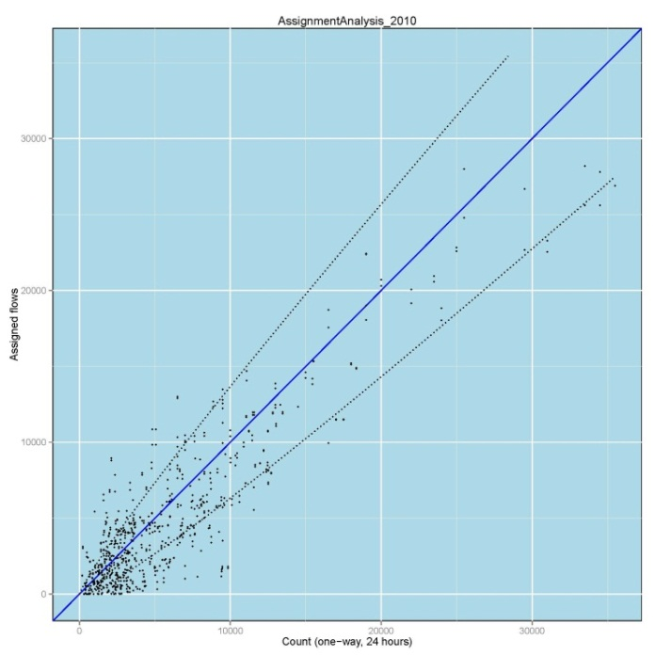

Figure ‑: Scatterplot of Total Model Volume and ADT (Sample)

Figure ‑: Scatterplot of Total Model Single Unit Truck Volume and Observed SUT Volume

Figure ‑: Scatterplot of Total Model Multi Unit Truck Volume and Observed MUT Volume

Figure ‑: Scatterplot of Model Auto Volume and Observed Auto Volume

## Other Validation

* Speed verification
* VHT comparisons
* Average Vehicle occupancy by mode
* VMT by county and facility type using traffic counts
* Modeled VMT versus HPMS data
* VMT/person
* VMT/HH
* VDF comparison
* Correlation Coefficient or Coefficient of Determination

1. Appendix A: Average Annual Daily Traffic Development (Optional)

1. National Cooperative Highway Research Program (NCHRP), Travel Demand Forecasting: Parameters and Techniques   
    (Report 716), TRB National Academy Press, 2012.
2. Plots should include key components of RMSE, % RMSE, Deviation as shown in Figure 6.1.